**Practical no.-**2

**Title:** Develop JavaScript to use decision making and looping statements.

**Roll No.:** **Batch-** A **Date of Performance:** 01/08/2023

**Code-**

<html>

<head>

<title>BG Colour</title>

</head>

<body>

<script type="text/javascript">

var val= prompt("Do you want to change BG Colour (yes/no) (Note:in lowercase only)");

if(val=="yes")

{

var val1 = prompt("Enter you favourite Colour for Background:");

document.body.style.background=val1;

}

else

{

alert("You decided not to change Colour");

}

</script>

</body>

</html>

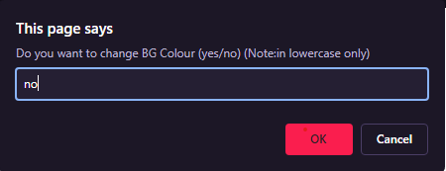**Output-**

